SITE SURVEY RESITE
COLLECTION CUSTOMER INFORMATION
Customer Name
Address
Model(s) |  |  |  |  | Opening Hours
 |  |  |  |  | Final Location (e.g. Department, floor)
Contact to call  Phone# |  |  |  |  | On-site Contact  Phone#
For resites, will the billing address change? | Yes |  | No |  | If Yes, New Billing Address:

COLLECTION AND VEHICLE ACCESS ISSUES
Delivery date/s
Height & Width restrictions | Yes |  | No |  | Comments
Weight restrictions | Yes |  | No |  | Comments
Parking restrictions | Yes |  | No |  | Comments
Location of building entry points
Number of steps (e.g. 0 – 10 includes door step)

Machines to be collected? | Yes |  | No |  | If no go to pg. 2 Internal access issues section
Collection serial no. | Same location as resite? |  |  |  | Same date as resite? |  |  |  | If resite date different specify alternative date/s
 | Yes |  | No |  | Yes |  | No
 | Yes |  | No |  | Yes |  | No
 | Yes |  | No |  | Yes |  | No
 | Yes |  | No |  | Yes |  | No
 | Yes |  | No |  | Yes |  | No

ADMIN ONLY | Order Number |  | Click Pack product |  | Yes |  | No
BRANCH ADMIN | SOP Number |  | CRM Number
COMMENTS

INTERNAL ACCESS ISSUES
Lift Available? |  |  | Yes |  |  |  | No |  |  |  | Weight Limit
Stairs (select most similar)
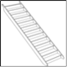 | 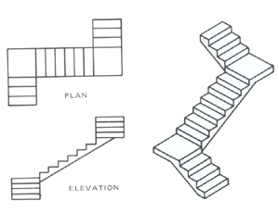 |  |  |  | 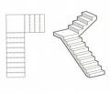 |  |  |  |  |  | 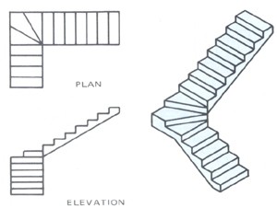 |  |  |  | 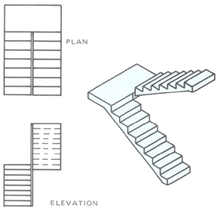 |  | 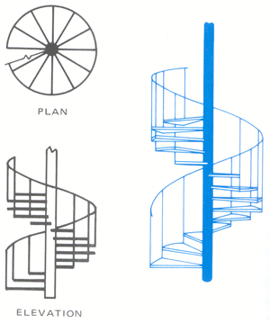
Number of Steps: |  |  |  |  |  |  |  |  |  |  | Number of Turns:
Flooring (e.g. carpet, uneven floor ramps)
Protection required? |  | Yes |  | No |  |  |  | Comments:
Access obstructions/hazards (e.g. narrow doorways) |  |  |  |  |  |  |  |  |  | Yes |  |  | No |  |  | Narrowest width:
Any other hazards/obstructions

Additional Comments

DELIVERY - CUSTOMER INFORMATION
Customer Name:
Address
Model(s) |  |  |  |  | Opening Hours
 |  |  |  |  | Final Location (e.g. Department, floor)
Contact to call  Phone# |  |  |  |  | On-site Contact  Phone#
For resites, will the billing address change? | Yes |  | No |  | If Yes, New Billing Address:

DELIVERY AND VEHICLE ACCESS ISSUES
Delivery date/s
Height & Width restrictions | Yes |  | No |  | Comments
Weight restrictions | Yes |  | No |  | Comments
Parking restrictions | Yes |  | No |  | Comments
Location of building entry points
Number of steps (e.g. 0 – 10 includes door step)

Machines to be collected | Yes |  | No |  | If no go to pg. 2 Internal access issues section
Collection serial no | Same location as delivery? |  |  |  | Same date as delivery? |  |  |  | If delivery date different specify alternative date/s
 | Yes |  | No |  | Yes |  | No
 | Yes |  | No |  | Yes |  | No
 | Yes |  | No |  | Yes |  | No
 | Yes |  | No |  | Yes |  | No
 | Yes |  | No |  | Yes |  | No

INTERNAL ACCESS ISSUES
Lift Available? |  |  | Yes |  |  |  | No |  |  |  | Weight Limit
Stairs (select most similar)
Number of Steps: |  |  |  |  |  |  |  |  |  |  | Number of Turns:
Flooring (e.g. carpet, uneven floor ramps)
Protection required? |  | Yes |  | No |  |  |  | Comments:
Access obstructions/hazards (e.g. narrow doorways) |  |  |  |  |  |  |  |  |  | Yes |  |  | No |  |  | Narrowest width:
Any other hazards/obstructions

Additional Comments

SURVEY COMPLETED BY | SURVEY APPROVED BY SALES MANAGER
Print Name: | Print Name:
Organisation: | Organisation:
Signature: | Signature:
Date: . | Date: .

Complete For Click Pack
Reseller Name: | Email:
Contact: | Telephone:
Incorrectly completed forms will be rejected
For more than six (6) machines complete Multiple Install Sheet
For machine re-site complete one (1) form each site

GUIDELINES FOR COMPLETING SITE SURVEY FORM

Delivery and Vehicle Access

- What size vehicle can access the site?
- Are there weight restrictions for the area?
- What parking is available? (Would a vehicle the size of a fire engine be able to park?)
- How far from the building is the parking?
- In the event that the machine is walked to the building from the parking, what type floor / ground is it? (e.g. smooth tarmac, cobble stones, neat paving slabs, rough paving slabs etc.)?
- Are there stairs to enter the building? How many? Made from?

Internal Access

Walk the path that the machine will take to get to the final destination.

- Can the machine fit through all the doors?
- If not sure on the measurements of a machine just ask.
- What is covering the floor and stairs (e.g. carpet, wood, marble etc.)?
- What is the maximum weight?
- What are its measurements? Both inside and width of the doorway.
- Is a lift available?
- If no lift, can a stair crawler be used?

- A different type of stair crawler will need to be used if:

- there is carpet on the stairs
- there are runners on the stairs
- the stairs are marble, wooden or steel
- A spiral staircase*

Stairs with no back require a specific kind of stair crawler so please make sure this is noted.

*A spiral staircase is any staircase which has at least one 180° turn (i.e. the stairs go back on themselves).

If there is a turn on the stair case you must remember the height of the machine becomes the width of the machine when using a stair crawler.

Measurements to be taken:

- Smallest width of the stairs
- Width at the top of the stairs
- Actual size of landing
- Width of the stairs at each flight.

